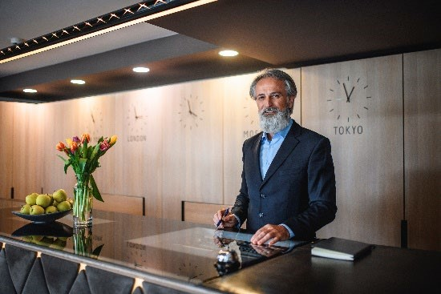

**OSU GRADTDA5622 – Big Data Computing Foundations 2**

**Instructor: Greg Ryslik; Semester: Spring 2024**

**Case Study 4: Deployment / Presentation**

**Objective:**

In this assignment, you will use the results of the work you did in Case Studies 1-3 on the Buckeye Resorts, Inc. (BRI) hotel dataset. You will create a report suitable for presentation to your organization’s stakeholders.

The objectives of this assignment are:

1. Understand how to communicate data analysis results in a concise way.
2. Understand how to communicate data analysis results to stakeholders who do not have data analysis expertise.
3. Understand how to support stakeholders’ needs to make decisions and take action.

**Problem Statement:**

Assume that you are the Director of Data Science for Buckeye Resorts, Inc. (BRI), an international hotel chain. As is the case for all hotel chains, reservation cancellations cause significant impacts to BRI, in profitability, logistics, and other areas. BRI wants to improve (decrease) the cancellation rates at its hotels, using more tailored interventions, based on newly available detailed data. In the earlier assignments, your team did some exploratory analysis to look for interesting patterns and insights, and created a model that predicts whether a customer is likely to cancel.

The head of BRI would like you attend the upcoming BRI Board of Directors meeting. She has asked you to present your findings to her and to the BOD, to help them decide whether to go forward with the planned tailored intervention approach, and/or to adjust or abandon the approach. **Your goal is to support the BOD in making a decision.**

**Deliverable:**

You will submit a Powerpoint (or equivalent) presentation report (in .PDF format). The slide deck must contain the following:

* The **main body** of the report may contain no more than 10 slides (including the cover page, but not including any (optional) appendices). It should be written in a way that the typical BOD member can understand it – no deep technical details!

* You may (optionally) choose to include one or more **appendices** for supporting material (e.g., in case, a BOD member has additional questions on details beyond what you cover in the main body of the report). This might include a bit more technical detail that will convince stakeholders that your analysis was thorough.

The **main body** of the report must cover, at a minimum:

1. Description of the original request (some BOD members may not be aware of the original request).

1. Description of the dataset.

1. Steps you took to analyze the data.

1. Results of your analyses.
   1. Evaluation of the usefulness/appropriateness of the data for this problem.
   2. Evaluation of significant insights you discovered (and/or your observations on the lack of significant insights).

1. Your recommendation for the BOD to move forward (or not) with the approach.

1. Discussion of how the various aspects of the data, etc., impacted the proposed approach and how changes to the approach might make the problem more tractable.
   1. That is, is the proposed approach sensitive to particular aspects of the current situation…? (You do not have to show, via detailed analysis, that a particular change would result in specific, predicted results.)

1. Discussion of possible next steps that it might make sense to take.
   1. Consider changes to data, methods, etc.

1. Conclusion / thank you.

How you group this information on slides is up to you, but try to follow this general pattern.

**Guidance:**

1. This must be a **concise** report. While you will not be presenting it, you should assume you could present it in 30 minutes. Assume you will be “speaking to” the slides, so they should not contain lots of text. However, the key points must be visible on the slides. Graphics are generally preferred to long text streams. Do not simply copy/paste the text from your earlier Case Study submissions. Consider your audience!

1. The audience will be made up of intelligent people who **do not** have a deep technical background in data analytics. They will be busy and “results-focused”, and not want to see lots of details unless the details are truly relevant. You may put details in the appendices if you choose.

1. This assignment is based on the earlier assignments, and you may or may not have gotten the results you hoped to get in the earlier assignments. Therefore, you may **choose to “adjust” or “extrapolate” your earlier results** when creating this presentation (to make a more interesting story).

**Collaboration:**

For this assignment, you should work as a team. You may informally discuss ideas with other classmates, but your work should be your (team’s) own. **Please make use of Slack!**

**What you need to turn in:**

**1) Written Report**

A. Turn in the presentation, in **.PDF** format.

**Grading Criteria:**

1. **Readability and organization of your report (40%)** - Is it concise and well organized? Does the presentation flow in a logical manner? Are there no grammar and spelling mistakes? Are the graphics readable?
2. **Usefulness of your report (50%)** – Does your report meet the needs of your business stakeholders? Does each slide provide value? Do the text and graphics support the purpose of each slide, and the narrative overall? Do you anticipate and address questions they might have? Will it help them make a decision?
3. **Tone of your report (10%)** – Is your report factual and unbiased? Are all opinions and recommendations labeled as such?

**How to turn in your work on Carmen:**

***Please follow these instructions exactly - it helps the grading process. If you have questions, please ask.*** Submit the report to Carmen, in **.PDF** format. **Do not Zip it or include any other materials.**

**References and Acknowledgements:**

a. N/A